

Assignment No: 5

Date: 19th October 2026

Title: AMI, Manchester, B3ZS and 4B3T using python

Name: Joe Blogs ???

Course: Bachelor of Engineering in Electronic Engineering

Subject: Digital Communications and Transmission

Lecturer: Ben Graham

Summary: To generate and investigate various line codes (AMI,Manchester,B3ZS and 4B3T) using python

OBJECTIVES:

After the completion of this experiment, students will have a good knowledge of the following line codes:

- Alternate Mark Inversion
- Manchester
- B3ZS
- 4B3T

EQUIPMENT REQUIRED:
Access to python on Kaggle.

THEORY:

AMI A binary 1 is coded as alternate +V and –V for 50% of the bit interval and a binary 0 as 0V for the total bit interval.

Manchester A binary 1 is coded as a +3 V to –3 V transition and a binary 0 as a –3 V to +3 V transition in the middle of the bit interval.

B3ZS Bipolar with Three-Zero Substitution

PST Pair Selected Ternary

4B3T 4 Binary 3 ternary block coding

Total Marks : 100

All work must be completed and submitted inside THIS Document

Part 1 – AMI – (Marks:10)

Question 1: What does AMI stand for? What is the fundamental operation of AMI, explain?
Is a variation of bipolar RZ format, during the bit interval, binary 0s are transmitted as no pulse. The operation of this method is while binary 1s, also called marks are transmitted as alternating positive and negative pulses. One binary 1 is transmitted as a positive pulse, while the next binary 1 is sent as a negative pulse. AMI is a blend of both level and transition codes, the binary 0 is a level code and the binary 1 acts like a transition code

- Using your python code from the previous lab 4, develop python code to generate AMI code for binary input 1011001.

The code will need to monitor the status of the previous mark

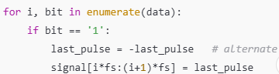

Code:

import numpy as np
import matplotlib.pyplot as plt

# Parámetros iniciales
bits = "1011001"
A = 1 # Amplitud de voltaje
bit_duration = 1
fs = 100 # Puntos por intervalo de bit (frecuencia de muestreo)

# Inicialización de la señal
total_duration = len(bits) * bit_duration
t = np.arange(0, total_duration, 1/fs)
signal = np.zeros_like(t)

last_pulse = -A # Comienza alternando desde +A

for i, bit in enumerate(bits):
if bit == '1':
last_pulse = -last_pulse # Alterna la polaridad para cada '1'
signal[i*fs : (i+1)*fs] = last_pulse
else:
signal[i*fs : (i+1)*fs] = 0 # El '0' se mantiene en 0V

# Gráfica
plt.figure(figsize=(10, 3))
plt.plot(t, signal, linewidth=2)
plt.ylim(-1.5, 1.5)
plt.xlabel("Time (s)")
plt.ylabel("Voltage (V)")
plt.title("AMI Line Coding for binary input 1011001")
plt.grid(True)
plt.show()
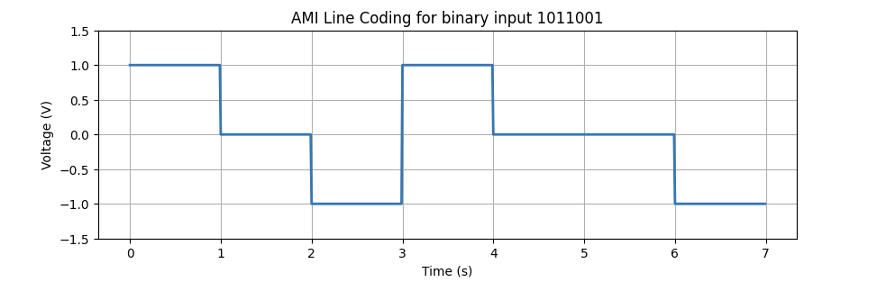
Figure 1: AMI Line Coding Waveform

Generate AMI output for ascii ‘U’.

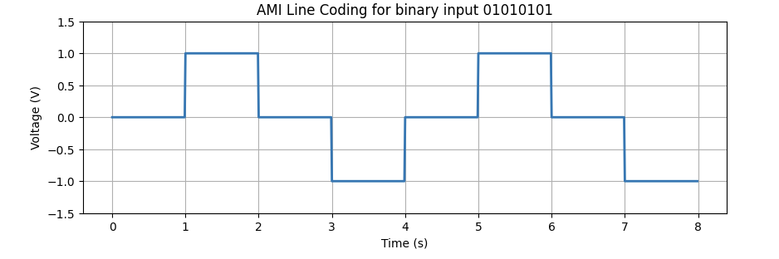
Figure 2: ASCII AMI Output for 'U'

The for loop goes through the bit string. If it finds a '1', it flips the sign of the last_pulse variable multiplying it by -1 and assigns that voltage level to the corresponding time interval of the signal. If it finds a '0', the signal stays at 0 V.
Part B – Manchester – (Marks:20)

Question 2: Explain the key features of Manchester coding
Manchester Coding is a Bi-Phase encoding and can be unipolar or bipolar. When a binary 1 is transmitted first as a positive pulse for one half of the bit interval and then as a negative for the remainder of the bit interval. And a binary 0 is transmitted first as a negative pulse for one half of the bit interval and then as a positive for the remainder of the bit interval. ______________________________________________________

Using your python code from the previous lab 4, develop python code to generate Manchester code for binary input 1011001 and for ASCII “!”

- Comment and explain key sections of the code

Hint
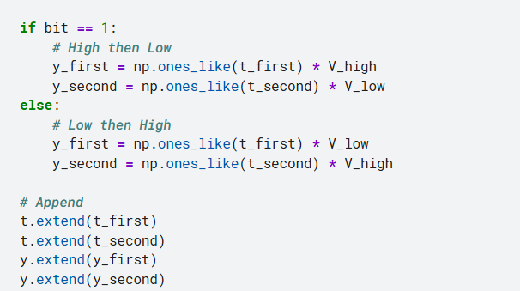

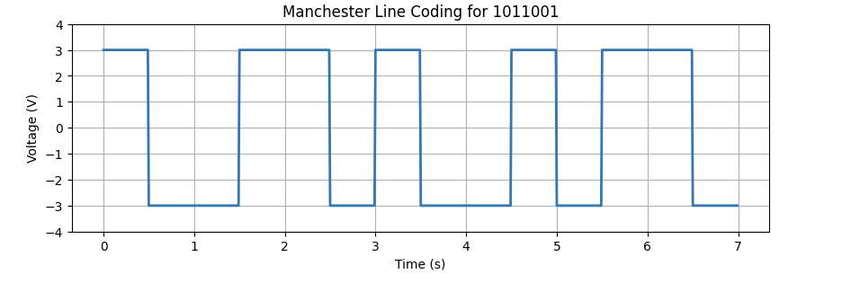
Figure 3: Manchester Line coding waveform for 1011001
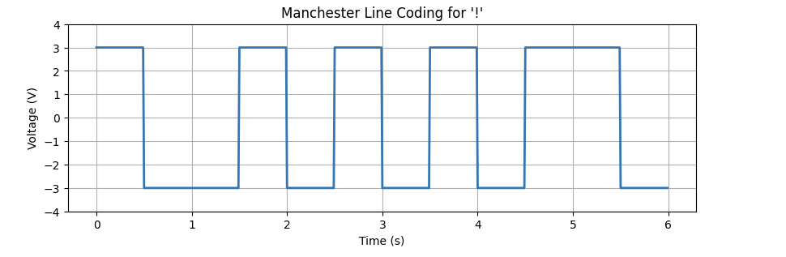
Figure 4: Manchester Line Coding Waveform for '!' (100001 in binary)
Key sections of the code
It's a biphase code where there are no voltage levels at 0 V to represent data unless there's no transmission. Each bit contains a mandatory transition in the middle of its interval, which ensures excellent clock recovery in the receiver. Where a bit 1 represents a transition from high to low, and a bit 0 represents a transition from low to high.

Part C – B3ZS – (Marks:20)

Question 3: Explain your understanding of B3ZS and what conditions need to be taken into account.
- In a B3ZS code, a string of three consecutive zeros is replaced by B0V or 00V. B is a pulse that follows the AMI convention and V is a pulse violating the AMI convention. B0V or 00V is chosen such that the number of bipolar (B) pulses between the violations is odd. The conditions to take in account are the number of data bits 'B' that have passed since the last violation 'V', the polarity of the last marked pulse (+ or -) and depending on whether the number of marks since the last violation is even or odd, the 000 pattern is replaced by B0V or 00V applying the correct polarity according to the dash table._______________________________________________________________

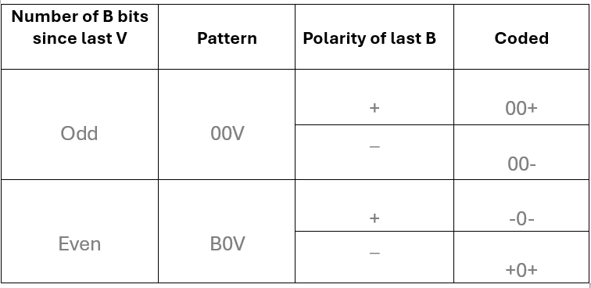

On paper, create the B3ZS waveform for the binary input 1011000101000011.

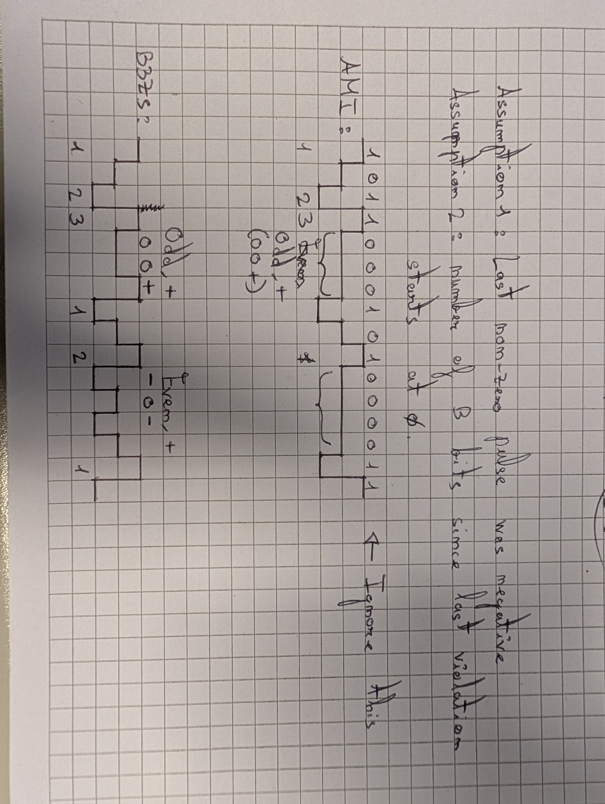

Develop python code to generate B3ZS for binary input 1011000101000011

Code:
import numpy as np
import matplotlib.pyplot as plt

# Input bitstream
bits = "1011000101000011"

# Parameters
V_high = 1
V_low = -1
bit_duration = 1

# Step 1: AMI encoding with B3ZS substitution
ternary_stream = []
last_polarity = V_low # start assuming last non-zero was -V (arbitrary choice)
marks_since_violation = 0
i = 0

while i < len(bits):
if bits[i:i+3] == "000": # found 3 zeros
print("Three 0s detected")
# Decide violation pattern based on state
if last_polarity == V_high:
if marks_since_violation % 2 == 0: # Even number of marks
pattern = [V_low, 0, V_low] # - 0 -
print("Last Pulse was high and bits since violation are even")
last_polarity = V_low
else: # Odd number of marks
pattern = [0, 0, V_high] # 0 0 +
print("Last Pulse was high and bits since violation are odd")
last_polarity = V_high
else:
if marks_since_violation % 2 == 0: # Even number of marks
pattern = [V_high, 0, V_high] # + 0 +
print("Last Pulse was low and bits since violation are even")
last_polarity = V_high
else: # Odd number of marks
pattern = [0, 0, V_low] # 0 0 -
print("Last Pulse was low and bits since violation are odd")
last_polarity = V_low

ternary_stream.extend(pattern)
marks_since_violation = 0 # reset after violation
i += 3
else:
# Parte que faltaba en la captura: procesa bits individuales ('1' o '0')
if bits[i] == '1':
last_polarity = -last_polarity
ternary_stream.append(last_polarity)
marks_since_violation += 1
else:
ternary_stream.append(0)
i += 1

print("Input bits: ", bits)
print("B3ZS encoded: ", ternary_stream)

# Step 2: Generate waveform
t = []
y = []

for i, sym in enumerate(ternary_stream):
t_sym = np.arange(i*bit_duration, (i+1)*bit_duration, 0.01)
y_sym = np.ones_like(t_sym) * sym
t.extend(t_sym)
y.extend(y_sym)

# Step 3: Plot waveform
plt.figure(figsize=(12, 4))
plt.plot(t, y, linewidth=2)
plt.ylim(-V_high-1, V_high+1)
plt.yticks([V_low, 0, V_high])
plt.xlabel("Time")
plt.ylabel("Voltage")
plt.title("B3ZS Line Coding - 1011000101000011")
plt.grid(True)
plt.show()

- Walk through the critical parts of your Python script. Outline and explain the core functionality of your Python code.
Variables de estado (last_polarity y marks_since_violation): Guardan en memoria la polaridad del último pulso y cuántos '1' se han transmitido desde la última violación.
Ventana deslizante (while i < len(bits) y bits[i:i+3] == "000"): Comprueba si los siguientes 3 bits son "000". Si lo son, evalúa la paridad (marks_since_violation % 2 == 0) y la polaridad previa para elegir entre [-1, 0, -1], [0, 0, 1], [1, 0, 1] o [0, 0, -1], reinicia el contador de marcas a 0 y salta 3 posiciones (i += 3).
Rama else (AMI estándar): Si no hay tres ceros seguidos, codifica un bit normal: si es '1', invierte last_polarity y suma 1 a marks_since_violation; si es '0', añade 0 voltios y avanza 1 posición (i += 1).

- Include your generated waveform here. Compare with the waveform you expected.
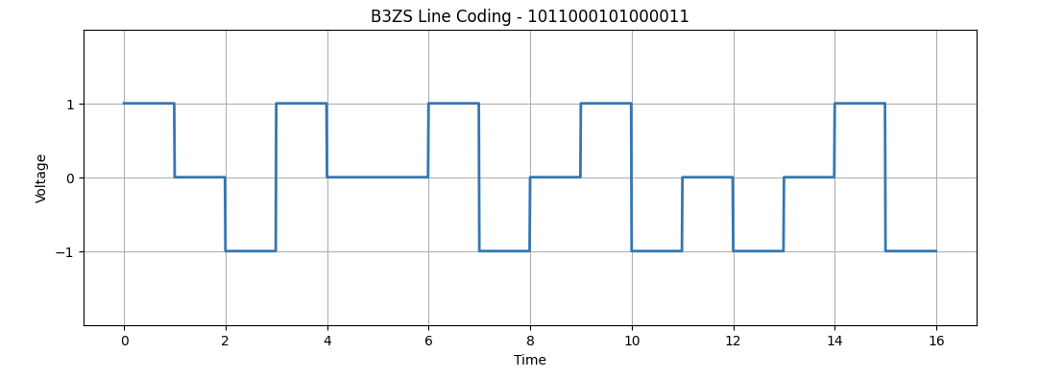
Repeat for 0x 2C28 (Hex). Assume previous mark was postive (+) and an odd number of marks since last violation.

Code:
import numpy as np
import matplotlib.pyplot as plt

# Conversión de 0x2C28 a 16 bits binarios: '0010110000101000'
bits = format(0x2C28, '016b')
last_polarity = V_high # Assume previous mark was positive (+)
marks_since_violation = 1 # Assume an odd number of marks (1 is odd)

# Parameters
V_high = 1
V_low = -1
bit_duration = 1

# Step 1: AMI encoding with B3ZS substitution
ternary_stream = []
last_polarity = V_low # start assuming last non-zero was -V (arbitrary choice)
marks_since_violation = 0
i = 0

while i < len(bits):
if bits[i:i+3] == "000": # found 3 zeros
print("Three 0s detected")
# Decide violation pattern based on state
if last_polarity == V_high:
if marks_since_violation % 2 == 0: # Even number of marks
pattern = [V_low, 0, V_low] # - 0 -
print("Last Pulse was high and bits since violation are even")
last_polarity = V_low
else: # Odd number of marks
pattern = [0, 0, V_high] # 0 0 +
print("Last Pulse was high and bits since violation are odd")
last_polarity = V_high
else:
if marks_since_violation % 2 == 0: # Even number of marks
pattern = [V_high, 0, V_high] # + 0 +
print("Last Pulse was low and bits since violation are even")
last_polarity = V_high
else: # Odd number of marks
pattern = [0, 0, V_low] # 0 0 -
print("Last Pulse was low and bits since violation are odd")
last_polarity = V_low

ternary_stream.extend(pattern)
marks_since_violation = 0 # reset after violation
i += 3
else:
# Parte que faltaba en la captura: procesa bits individuales ('1' o '0')
if bits[i] == '1':
last_polarity = -last_polarity
ternary_stream.append(last_polarity)
marks_since_violation += 1
else:
ternary_stream.append(0)
i += 1

print("Input bits: ", bits)
print("B3ZS encoded: ", ternary_stream)

# Step 2: Generate waveform
t = []
y = []

for i, sym in enumerate(ternary_stream):
t_sym = np.arange(i*bit_duration, (i+1)*bit_duration, 0.01)
y_sym = np.ones_like(t_sym) * sym
t.extend(t_sym)
y.extend(y_sym)

# Step 3: Plot waveform
plt.figure(figsize=(12, 4))
plt.plot(t, y, linewidth=2)
plt.ylim(-V_high-1, V_high+1)
plt.yticks([V_low, 0, V_high])
plt.xlabel("Time")
plt.ylabel("Voltage")
plt.title("B3ZS Line Coding - 0010110000101000")
plt.grid(True)
plt.show()
- Include your generated waveform here. Discuss output
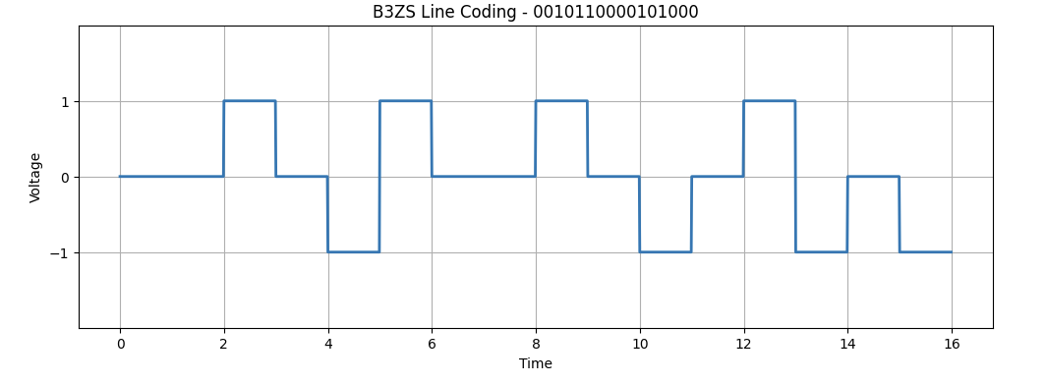

Hint:

Remember to generate the wave form:
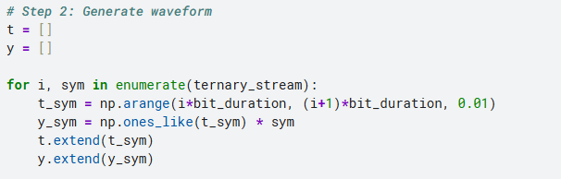

Part D-PST – (Marks:20)

Question 4: Explain your understanding of the operation of PST encoding

PST is a block-coding scheme that groups binary data into pairs of 2 bits (00, 01, 10, 11) and translates each pair into a 2-symbol ternary codeword using +, -, and 0 levels. To prevent DC component build-up, the encoder operates in two alternating modes: + Mode and - Mode. Pairs with balanced pulses (11 $→$ +- and 00 $→$ -+) have zero DC weight and do not switch modes. However, pairs with a single non-zero pulse (10 and 01) carry a net charge, so they use the current mode's polarity and trigger a mode switch (from + Mode to - Mode or vice versa) for the next pair, ensuring that every net pulse is balanced by the next one.
____________________________________________________________

- Solve on paper for in 0xB52E (Hex). Assume – Mode to start. Include an image of the output waveform and decisions taken

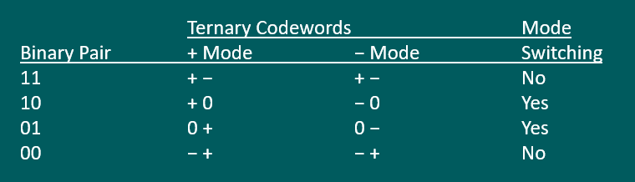

Part E-4B3T – (Marks:20)

Question 5: Explain your understanding of 4B3T, what conditions need to be taken into account and the steps that have to be taken. Refer to Notes

___________________________________________________________________

- Develop the 4B3T coding and output waveform on paper for binary input 101100010100001101011101. Include images of your working out in the report. State any assumptions. Note : I = 1
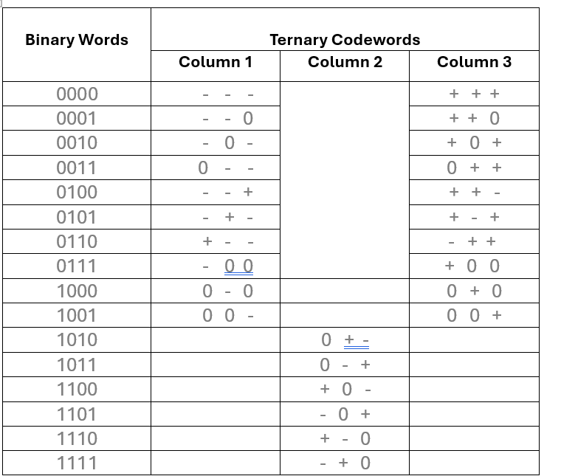

- Using the python code attached, run and confirm if it is correct.

- Highlight and discuss the various sections of the code.

Code shown attached in blackboard:

Part E – Conclusion – (Marks:10)
Explain the main characterises of each coding scheme, the steps taken when creating them and any advantages and disadvantages of each

